

Mohammad Ali Jinnah University

Chartered by Government of Sindh - Recognized by HEC

**Assignment 4**

**Name:** Muhamad Fahad

**Id:** FA19-BSSE-0014

**Subject:** [Linear Algebra (Fall 2020)](https://classroom.google.com/u/0/c/MTgxNTU3ODEwMjQw)

**Section:** AM

**Teacher:** Dr. Asmat Ara

**Date:** Saturday, December 26, 2020

Q.1 Solve the following system by Gaussian Jordan method. 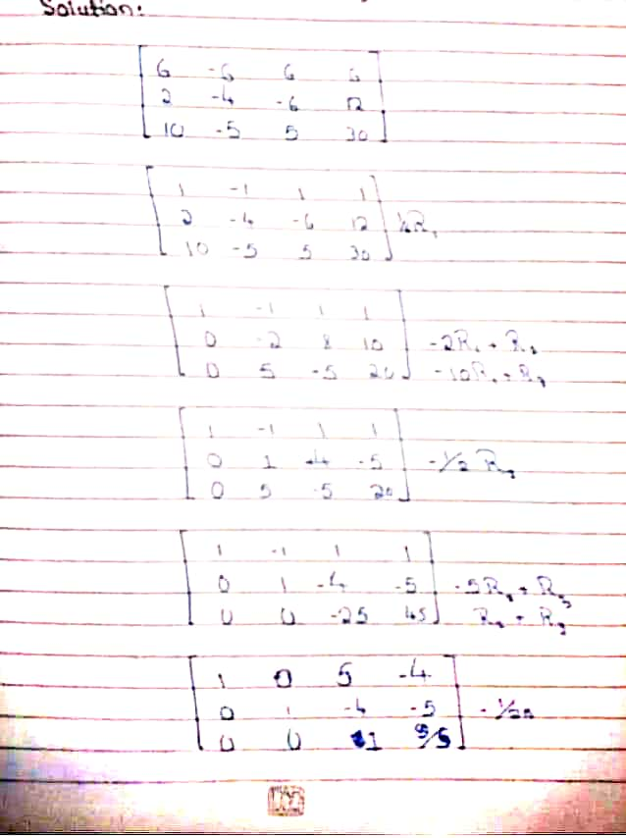

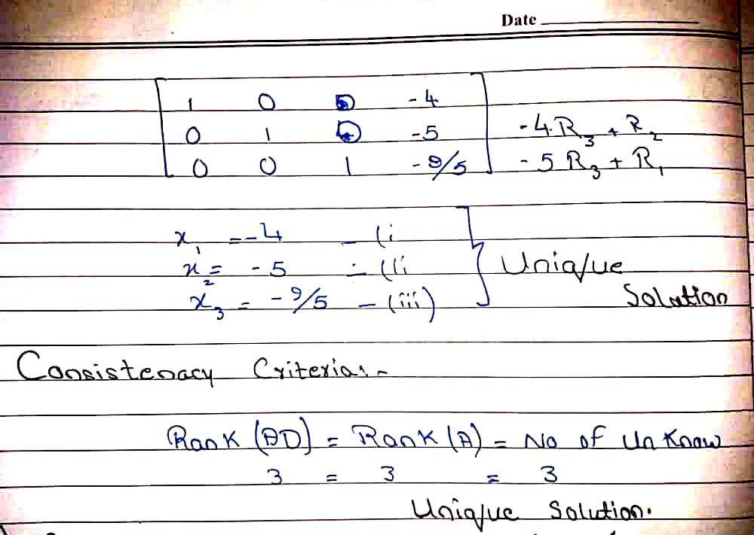

**Q.2 Show that.** **is an idempotent matrix.**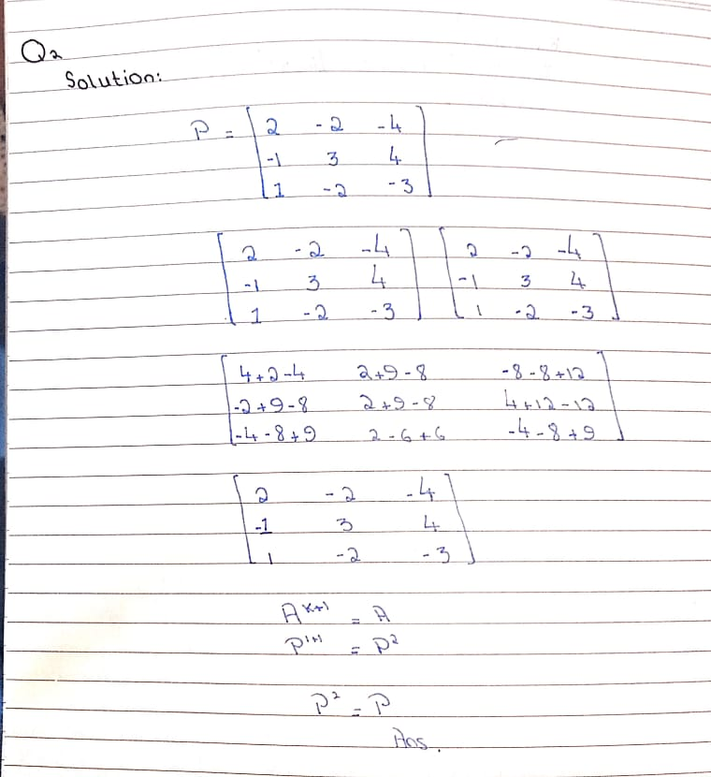

**Q.3 Find the inverse of the following matrix.**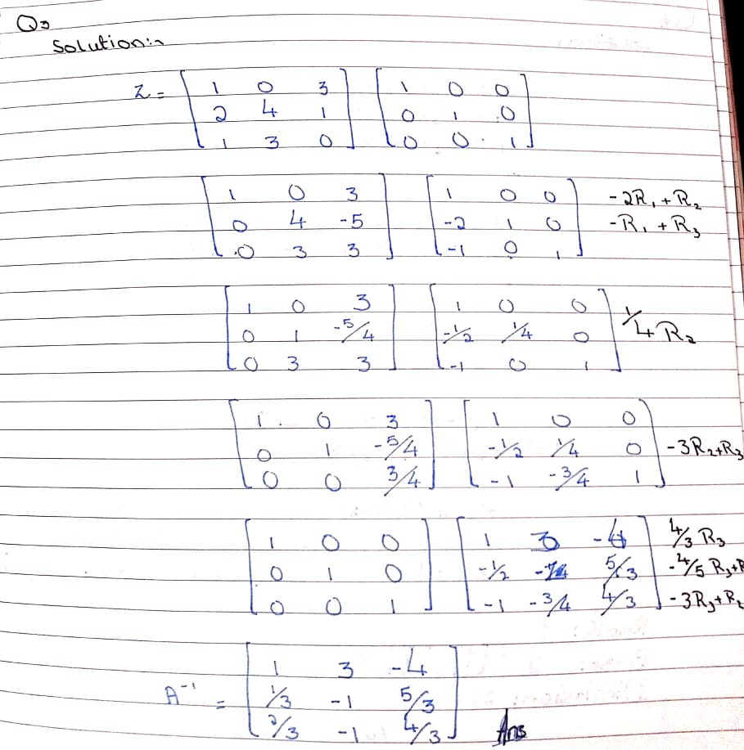

**Q.4 Find the basis and dimension for the solution space of the system.**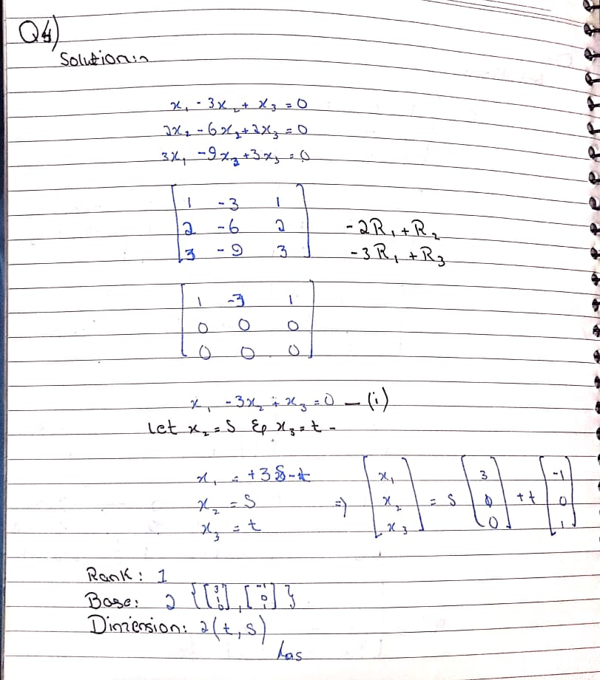

**Q.5 Determine whether the following vectors in R4 are linearly 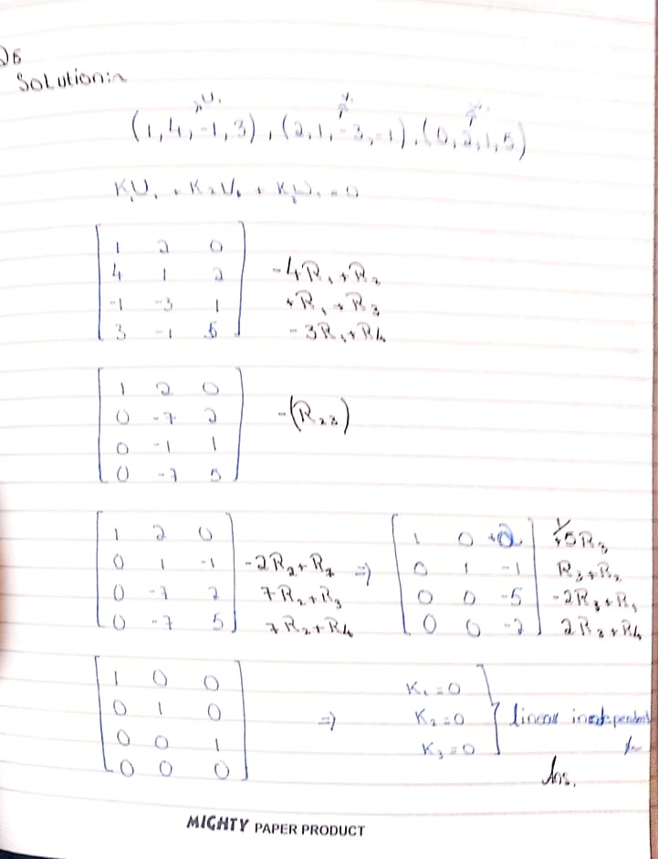iQ.6 Reduced the matrix**